MAP1_14 quick reference

Ray Meddis, University of Essex, Colchester, UK CO7 9SW.

Email: rmeddis@essex.ac.uk.
Update 27 May 2011

MAP1_14.m is a simple and fast version of the MAP model. It is a single function that includes all stages of the auditory periphery. MAP1_14 has full efferent functionality; both acoustic reflex and MOC efferent functions are automatically enabled.
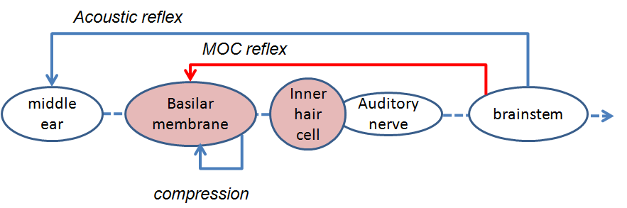
Figure #. Schematic of the auditory pathway modelled by MAP1_14.

Folder structure
The model is contained in a function called MAP1_14.m. This function can be found in MAP1_14*\MAP. The ‘*’ allows for version changes within the MAP1_14 series.
Other folders within MAP1_14* include parameterStore, utilities, wavFileStore and testPrograms. Another folder is called ‘multithreshold 1.46’. This contains psychometric testing software which can be harnessed to the MAP model.
Note: the modules folder to be found in earlier versions of MAP no longer exists as the program is no longer modular in the interests of speed

test_MAP1_14.m
To get started, you can use the simple test programs in the testPrograms folder. Two programs ‘demoTwisterProbability’ and ‘demoTwisterSpikes’ both take the acoustic input from a .wav file called ‘twister_44kHz.wav’ and process it through the model. The first plots the auditory nerve (AN) high-spont (HSR) and low-spont (LSR) response in 21 channels with BFs between 250 Hz and 8 kHz . It also plots the output of the three previous stages (stimulus, stapes and BM). The second computes the AN response as actual spikes and then uses these spikes as the input to arrays of cochlear nucleus and inferior colliculus cells. In both cases the cells are configured as simple chopper cells.
The output of the two programs looks something like this.
demoTwisterProbability .m demoTwisterSpikes.m
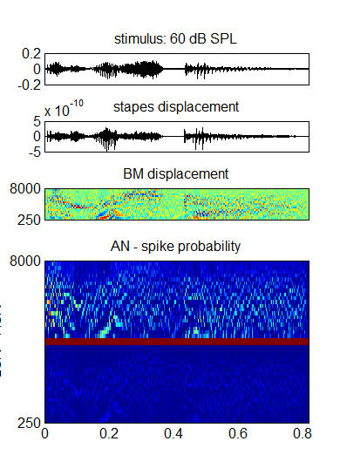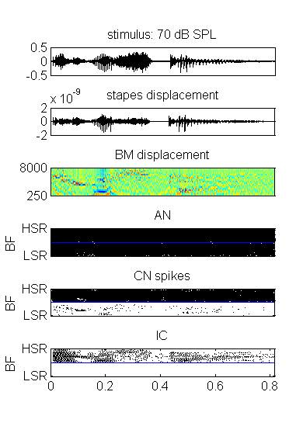
Figure #. The AN output in both figures has HSR output at the top of the panel and LSR output at the bottom of the panel. In the figure on the right the CN and IC units at the top of each panel are driven by the HSR activity and those at the bottom driven by LSR activity.
The model used has the architecture in Fig. #.
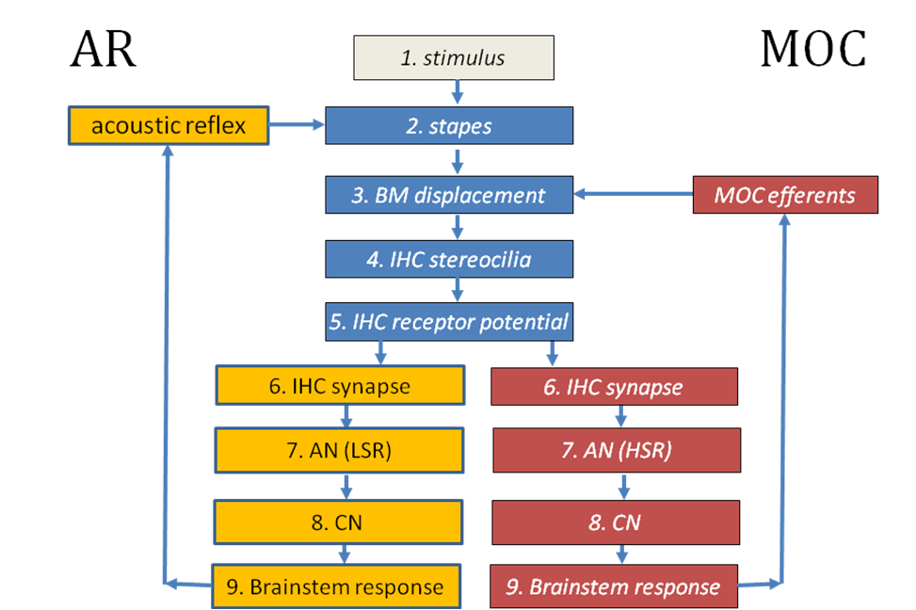
Figure #. Flow diagram of the model implemented in MAP1_14*.
‘test_MAP1_14’ (in the testPrograms folder) is a general purpose testing program that can be used to explore MAP1_14 more thoroughly. This program offers various options. Hopefully, these should be self-explanatory as you read through the program.
If the following options are selected in test_MAP1_14:
MAPparamsName='Normal';
AN_spikesOrProbability='probability';
signalType= 'file';
fileName='twister_44kHz';
leveldBSPL= 70; % dB SPL
numChannels=21;
lowestBF=250; highestBF= 8000;
paramChanges=[ ];

You should get an output that looks something like the figure immediately below. This is basically the same as the figure above but is associated with two other figures. One gives a surface plot featuring only the HSR AN fiber firing-probability output. The other shows how the efferent functions have been activated. In this example (using a 70 dB speech signal) the AR reflex is hardly activated and the MOC reflex (which operates on a channel by channel basis) is moderately activated.
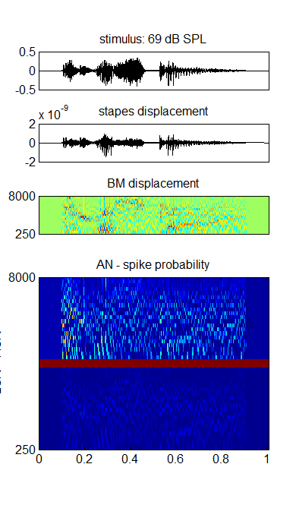 | 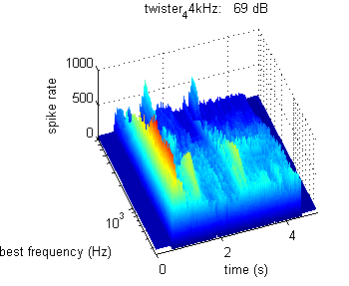
 | 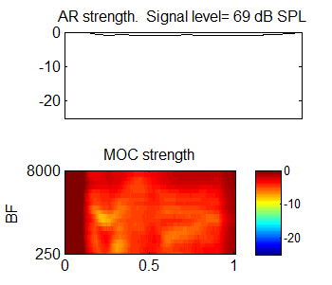

MAP1_14.m
The function that runs the model is MAP1_14 and is located in the MAP subfolder. The function call is
MAP1_14 (inputSignal, sampleRate, BFlist, MAPparamsName, AN_spikesOrProbability, paramChanges)
inputSignal is a single row vector in Pascals. It is a row vector because the model code always regards the x-axis of a matrix as the time axis. It is single row because the model only processes mono signals.
sampleRate is sample Rate (Hz)
BFlist is a vector of BFs (in Hz) but can be ‘-1’. In the latter case the list of BFs is based on the default values specified in the parameter file (see immediately below).
MAPparamsName e.g. ‘Normal’, is a string used to make up the name of parameter file (e.g. ‘MAPparamsNormal’). The parameter file contains all of the parameters of the model. Parameter files (all called MAPparams<*>) are always located in the folder called parameterStore.
AN_spikesOrProbability
=’probability’ for AN model based on probabilities (best for Speech recognition). This option computes very much faster that the alternative ‘spikes’ option but has some drawbacks.. Also the efferent control (AR and MOC) is based on AN firing rates which is unrealistic.
=’spikes’ for full model generating individual spikes in AN as well as models of CN and IC neurons.
paramChanges is a cell array of strings containing commands to change model parameters after loading them from the MAPparams<*> file. This argument is optional. Calling programs can use this facility to explore the effect of parameter changes without disturbing the precious parameter file. For example,
paramChanges{1}= 'DRNLParams.a=0;' ;
This example sets the corresponding variable to zero and disables the nonlinear path in the DRNL model of BM response (in effect, disabling OHC function).
These parameter changes overrule whatever is to be found in the MAPparams*.m function. To set up a string, copy it from the parameter file, add single quote marks and make the change you require. The changes are made in the MAPparams<*>.m function execution immediately before exiting the function.

Outputs
The MAP1_14 function returns no outputs directly. All results are stored in global variables. The most commonly required result will be the matrix ANprobRateOutput which is a BFlist x time matrix of estimated spiking rates using the sample rate specified in the function call. The time axis is sampled at the sampleRate requested above. ANprobRateOutput contains probabilities between 0 and 1 representing the estimated average probability of firing of AN fibers at a particular BF. This is only computed is the ‘probability’ option is chosen.
If the full spiking model is chosen (‘spikes’), the function generates ANoutput, CNoutput ,and ICoutput as logical matrices containing the rasters of spikes at each level. Each row in the matrix represents the firing of a single AN fiber or a single CN or IC neuron.
All values are international units (m, s, Pa, V, A)
The following global statement gives the calling program access to all important results
global dt ANdt savedBFlist saveAN_spikesOrProbability saveMAPparamsName...
savedInputSignal OMEextEarPressure TMoutput OMEoutput ARattenuation ...
DRNLoutput IHC_cilia_output IHCrestingCiliaCond IHCrestingV...
IHCoutput ANprobRateOutput ANoutput savePavailable tauCas ...
CNoutput ICoutput ICmembraneOutput ICfiberTypeRates MOCattenuation

Examples of output stored in global variables
The variable saveAN_spikesOrProbability in the testMAP1_14 program indicates whether ‘spikes’ or ‘probability’ computations were requested.
If MAP1_14 is run in probability mode, the AN spike rate matrix (BF x time) can be found in ANprobRateOutput. If only one type of AN fiber is requested, each channel refers to a single best frequency (BF). The list of best frequencies can be found in savedBFlist. If two fiber types are used (e.g. HSR and LSR), the top half of the matrix will be the output from one type of fiber and the bottom half from the other. By convention, the LSR fibers are located at the top of the matrix which is flipped in most plots to put the HSR at the top of the picture. The sampling interval for ANprobRateOutput is saved in the variable dt.
If MAP1_14 is run in spikes mode, the AN spiking output will be found in the matrix ANoutput. This is a logical matrix (0/1). The sampling interval is ANdt. The sampling rate is different (lower) for these computations because spikes are relatively sparse. Each row of this matrix is an individual fiber. The matrix is essentially a raster plot. Each BF is associated with many fibers (typically 100). All fibers with the same BF and fiber type are in adjacent rows. Fiber types are segregated with HSR fibers at the bottom of the matrix if more than one type has been requested. In most plots the matrix is flipped to put HSR fibers at the top.
In both cases the amount of efferent activity can be monitored using the variables ARattenuation (single row vector) and MOCattenuation (matrix BFs x time).

Program structure
MAP1_14 has two stages; the first allocates memory and does all computations that need be done only once. The second stage computes the model, segment by segment, as quickly as possible. The model is updated in segments to allow for efferent feedback (AR and MOC) to be implemented. The segments are typically 10 ms long.

UTIL_showMAP.m
This is a general purpose function reporting and plotting the output from the most recent MAP1_14 call. It assumes that all results are already present in global storage. It was used to generate the figures shown above.
UTIL_showMAP.m is located in the utilities folder. Here is an example of its output when running the model in ‘spikes’ mode.
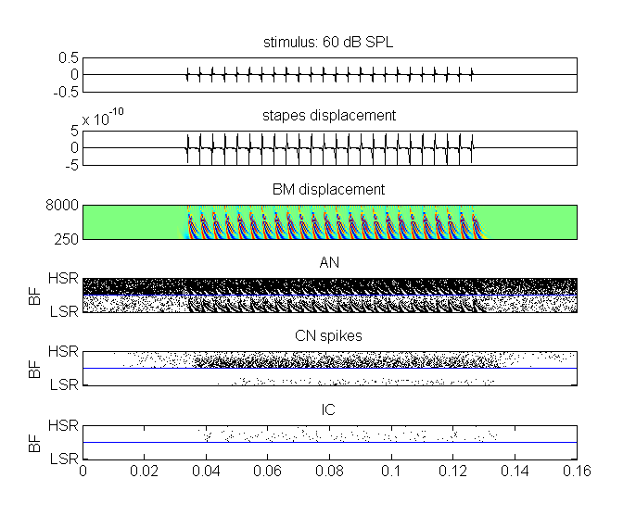
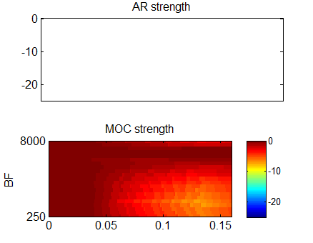
Fig #. UTIL_ showMAP output after a test_MAP1_14 run. A spiking model has been chosen and the stimulus is a pulse train consisting of all harmonics of F0=250 Hz up to 8 kHz (50 dB SPL per harmonic). Note that the spike patterns of AN, CN and IC units are divided into two halves because LSR (top half of each panel) and LSR (bottom half) are used. The right-hand panel shows the pattern of AR and MOC attenuation. There is no AR but the MOC attenuation builds up to moderate levels as the signal continues.
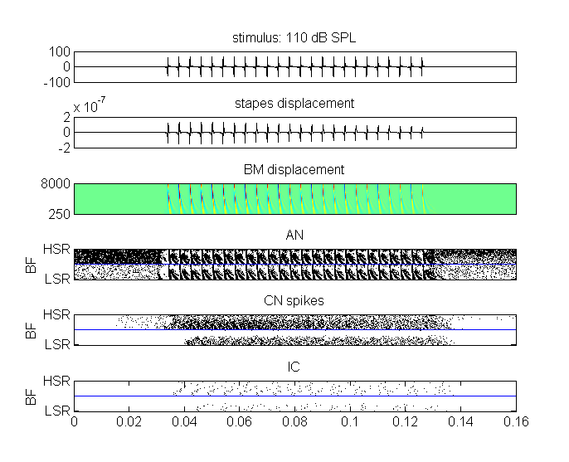
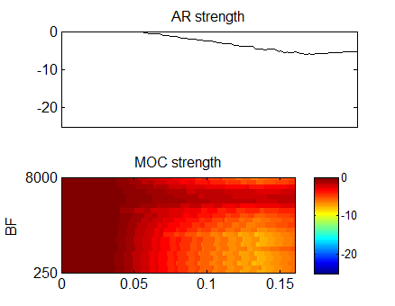

Fig #. UTIL_showMAP output after a test_MAP1_14 run (same as Fig. 2 but the individual harmonics are more intense at 100 dB SPL each). The right-hand panel shows the pattern of AR and MOC attenuation. On this occasion (compare previous figure) the AR is now active.

Warnings
The current version makes no checks on model parameters in terms of how sensible they are. However, all parameters are in international units and must be physiologically plausible.
The program ships with a set of model parameters in the parameter file ‘MAPparamsNormal’. These parameters are simply the values that the author has found to be most satisfactory. They are not perfect. If you wish to use them for research purposes, you should ask the author (rmeddis@essex.ac.uk) for the latest versions and any documentary support. This is cutting-edge stuff and, no, it is not yet published.

